Create a folder named express-demo

Move to that colder and open vs code in that folder

Create package.json file by executing below command

* npm init –y

Create a server.js file (creating express server)

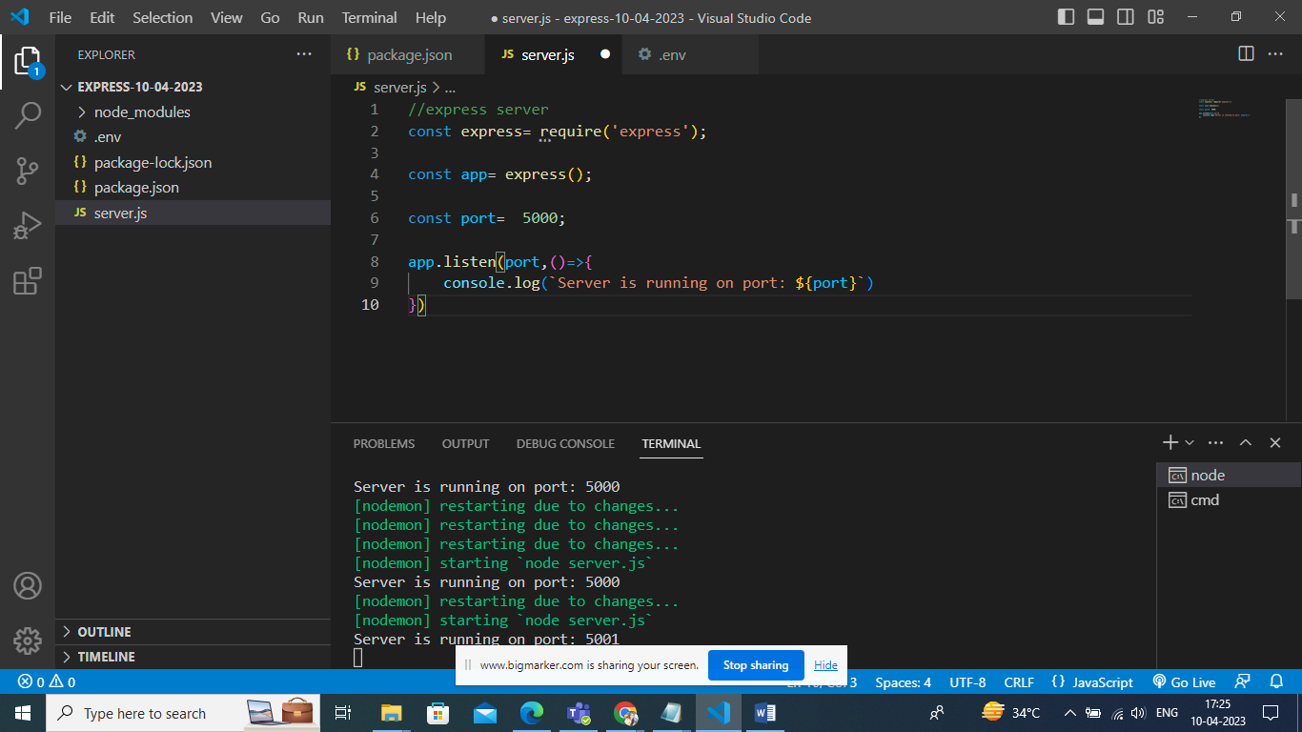

To run server install nodemon

Edit package.json

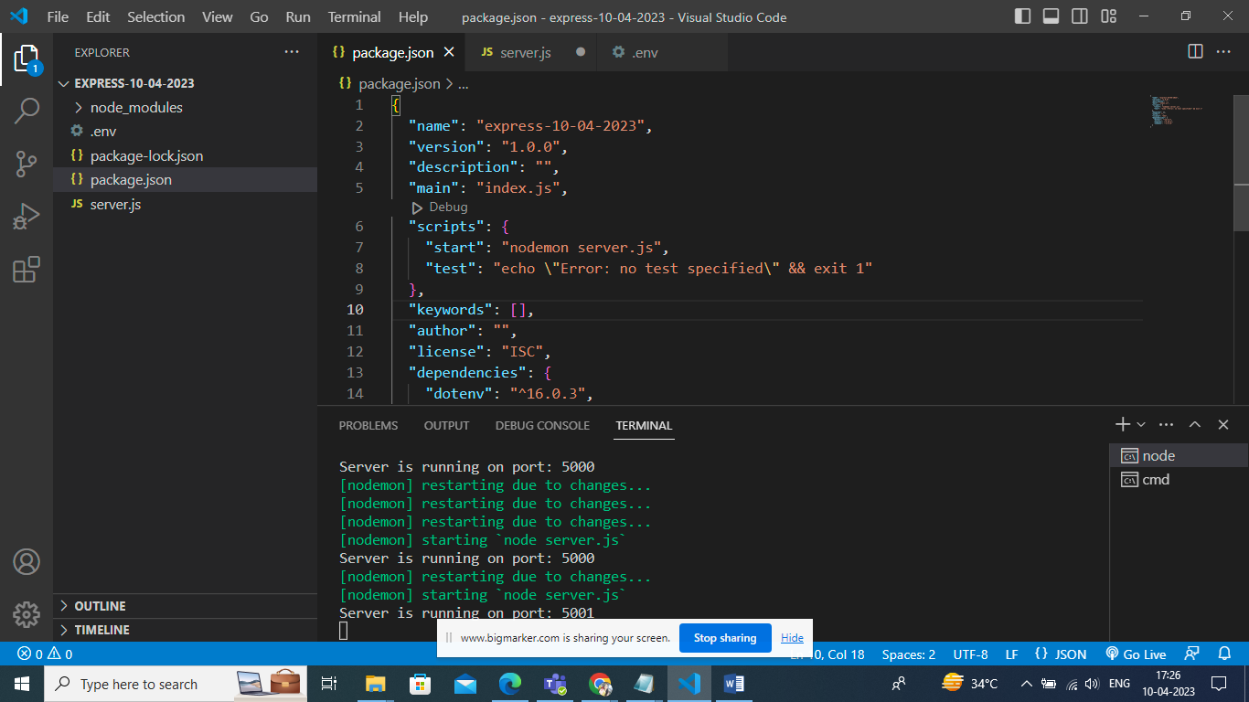

Run below command to start express server

* npm run start

to configure environmental files create .env file to your folder

PORT=5001

To use env file install dotenv module

* npm I dotenv

Edit server.js file to use port no from env file

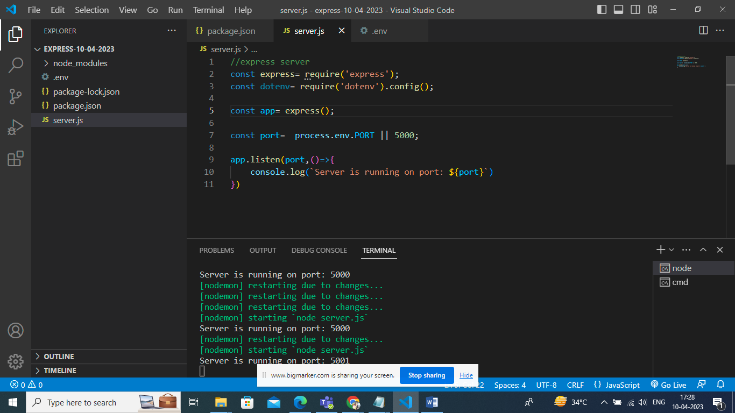

For configuring routes create a folder named routes and create file named contactRoutes.js

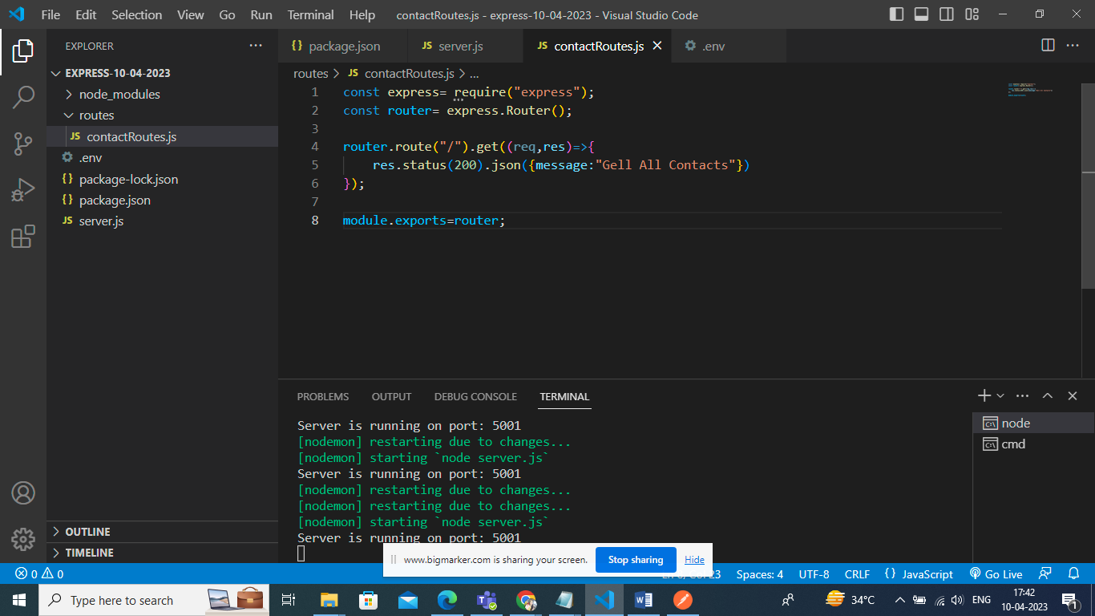

Nor use this routes file register the same in server.js

app.use("/app/contacts",require("./routes/contactRoutes"))

create Controller folder and create contactController.js file inside the same.

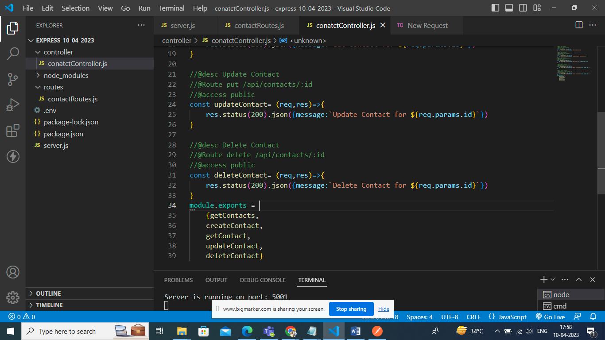

After creating controller use methods in routes.

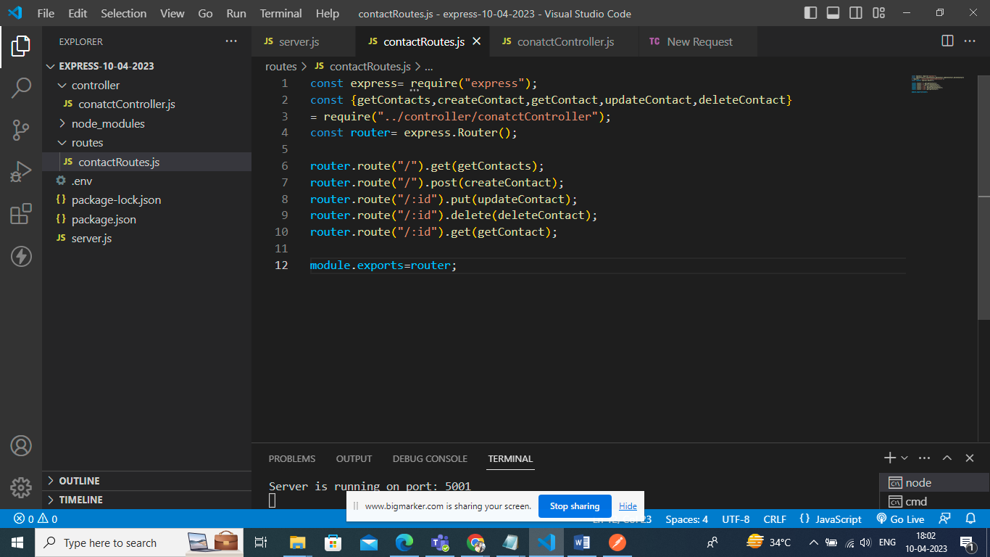

If you want to pass json data from api to backend you need to set the middleware provided by express only. Edit server.js file by including below line.

app.use(express.json())

If we pass empty object it should throw an error

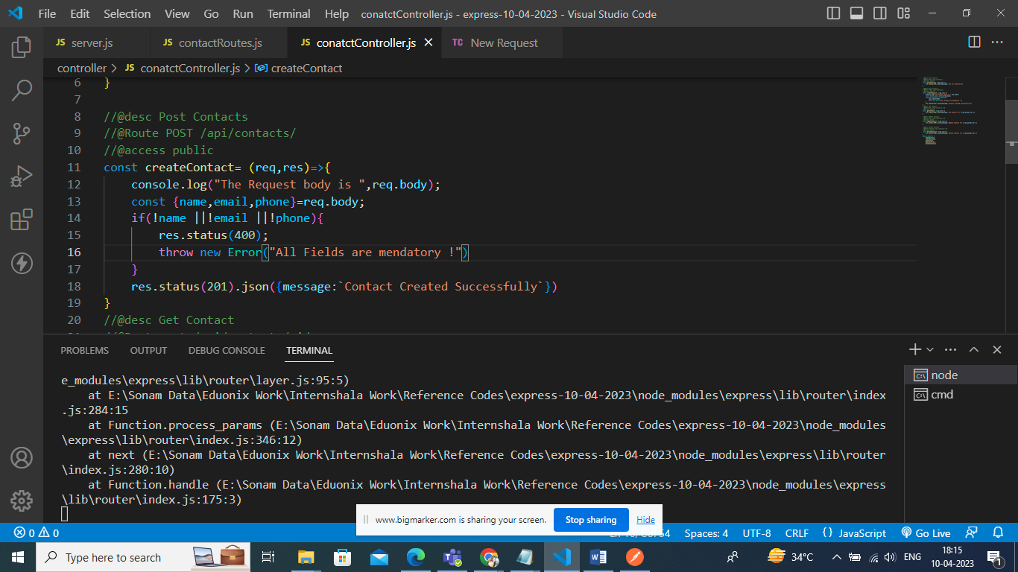

Once Its updated now you see error in response.

Create a folder named middleware and create a file errorHandle.js

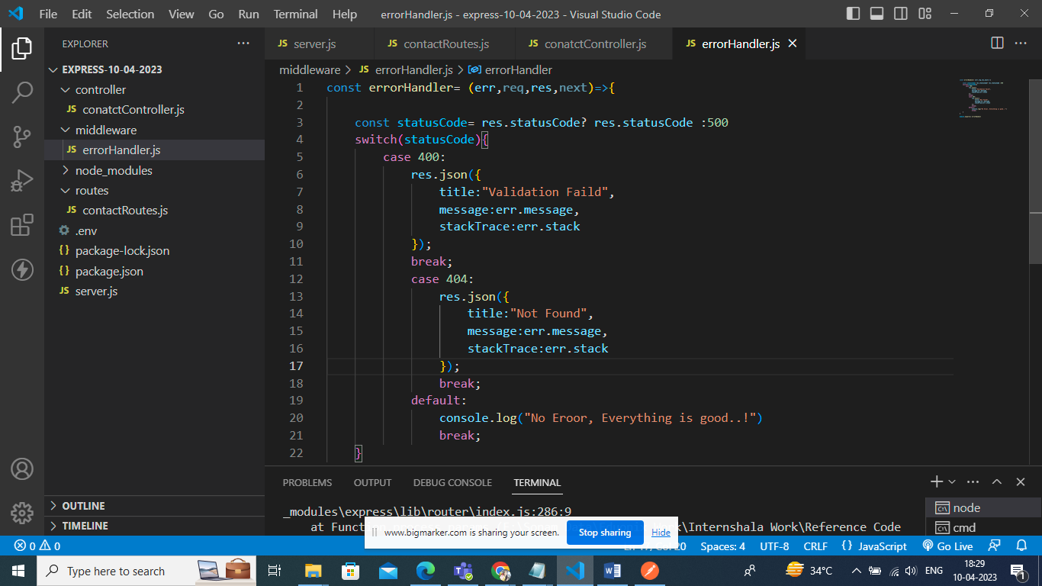

Register in server.js file

Add this line below the configured routes.

app.use(errorHandler)

when you use database for connectivity and trying to get data from the same which ia basically returning the promises where you need handle error by using catch and pass it to error handler .

This you can directly manage by asyncHandler

Install: npm I express-async-handler

Update the controller code as below.

